ECTATIC CORONARY VESSELS WITH MULTIPLE GIANT ANEURYSMS
K. Tan, F. Kho, I. Syed
Khoo Teck Puat Hospital, Singapore

Background: Coronary ectasias are rare, but coronary aneurysms are even rarer.
Method: We describe an elderly patient with such coronary anomalies, presenting to us with acute coronary syndrome. To the best of our knowledge, this is the first case describing triple vessel ectasias with coexisting multiple giant aneuryms in an elderly individual.
Abbreviations: LAD – left anterior descending artery; LCx – left circumflex artery
Results and conclusions: A 75-year-old Indian man, with a history of heavy smoking, presented with four-day history of chest pain. His ECG on arrival showed anterior hyperacute T-wave with elevated troponins. A coronary angiography was immediately performed on him.
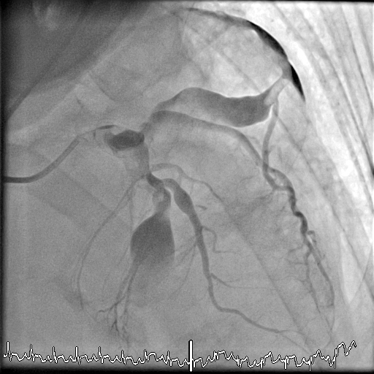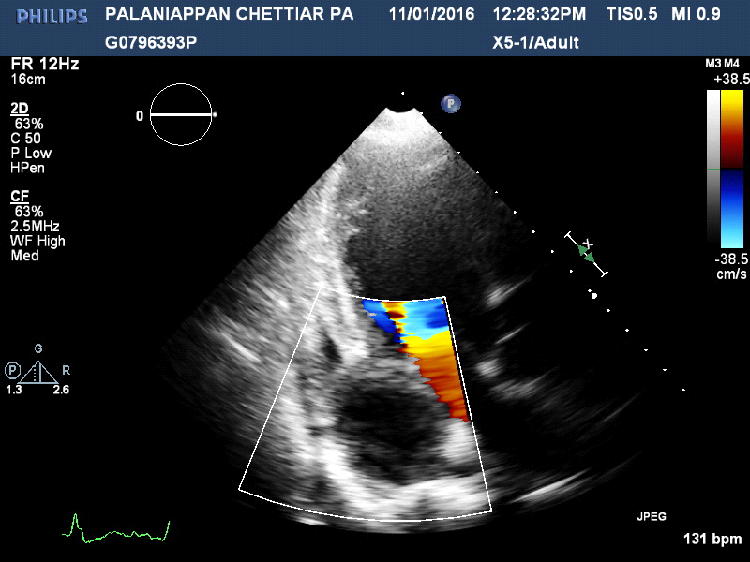On angiography, his three epicardical coronary arteries were ectatic with aneurysmal segments in the LAD (10mm) and LCx (50mm). The mid-LAD was not visualised after the aneurysmal segment, representing the culprit occlusion. The LCx beyond the mid-segment giant aneurysm was also not well visualized, likely due to a silent thrombosis (Figure 2). No percutaneous intervention was attempted due to high thrombus burden in the aneurysmal segment. Transthoracic echocardiography showed segmental wall abnormalities in the anterior and lateral walls. The mid-LCX giant aneurysm was captured in the atrioventricular groove beside the coronary sinus. He was started on subcutaneous enoxaparin
Figure 2: AP cranial projection Figure 3: Apical 2-chamber view
The patient was asymptomatic following anticoagulation. Relook invasive and computed tomography coronary angiography was not performed due to patient’s financial constraints. He was started on long term oral anticoagulation and discharged with subsequent follow up in India.

